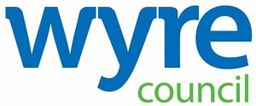

LICENSING ACT 2003 – Section 51

Application For Review of a Premises Licence

### NOTICE IS HERBY GIVEN THAT an application has been made to Wyre Council as the Licensing Authority for a review of the premises licence in respect of the premises shown below.

Any other person or responsible authority may make representations in respect of this application for review.

Such representations must be made in writing to the Licensing Manager, Wyre Council, Civic Centre, Breck Road. Poulton le Fylde. FY6 7PU, between the dates shown below.

Further information, including forms which may be used to make representations, may be obtained from the Council’s website at www.wyre.gov.uk/licensing or from the Licensing Team at the above address.

It is an offence to knowingly or recklessly make a false statement in connection with an application and the maximum fine for which a person is liable on summary conviction is £5000.

# NAME AND ADDRESS OF PREMISES: **The Cube, 2 Breck Road, Poulton-le-Fylde, FY6 7AA**

REPRESENTATIONS MAY BE MADE BETWEEN THE FOLLOWING DATES:

From: 24 January 2025 Until: midnight 20February 2025.

THE GROUNDS OF THE APPLICATION FOR REVIEW ARE:

There is evidence that activities have taken place which undermine all four licensing objectives.